Patient name: |  |  |  |  | Date:
Primary Care Physician: |  |  |  | Referring Physician:
Pharmacy Name and Location:

What is the main reason for today’s visit?
☐ Auto accident ☐ Injection ☐ MRI review ☐ New issue
☐ Other, please specify:
Are you currently using any of the following (check all applicable):
☐ Back Brace
☐ Chiropractor
☐ Cane
☐ Physical Therapy
☐ Walker
Please mark an (X) where you are currently having pain.
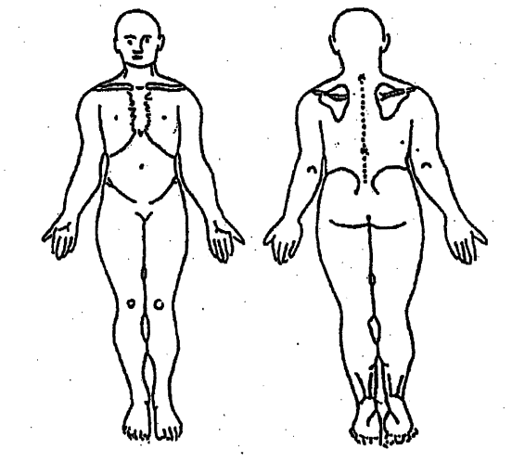
Left
Right
Left
Right
How would you describe the pain?
Type of Pain | Location |  | Type of Pain | Location | Type of Pain | Location
Burning |  |  | Numbness |  | Sharp
Cramping |  |  | Pins, needles |  | Shooting
Dull, aching |  |  | Pressure |  | Throbbing
Other, please specify:

Circle the current level of pain that you are experiencing.
 | No pain |  |  |  |  |  |  | Severe pain
Without Medications | 0 | 1 | 2 | 3 | 4 | 5 | 6 | 7 | 8 | 9 | 10
With Medications | 0 | 1 | 2 | 3 | 4 | 5 | 6 | 7 | 8 | 9 | 10

Percent of overall improvement since last procedure/visit? %
PLEASE COMPLETE THIS INFORMATION EACH VISIT.
Medication Related to Pain  (Include all muscle relaxers, anti-inflammatories, nerve pills, OTCs.) | What times of day is it taken? | Refill Needed?
Please provide a COMPLETE LIST OF YOUR MEDICATIONS to the front desk.
If you have any new medical issues or doctor visits since last visit, please identify.

Please check the items that you are currently experiencing.

Signs & Symptoms | Yes | No
Night sweats
Fever or chills
Unplanned weight loss
Unplanned weight gain
Easy bruising
Easy bleeding
Rashes
Low platelet count
Changes in vision, taste, hearing, smell
Difficulty breathing
Shortness of breath
Wheezing
Palpitations (awareness of fast heart)
Chest pain
Abdominal pain
Nausea
Vomiting
Diarrhea
Incontinence of bladder or bowel
Back pain
Neck pain
Joint pain (knee, elbow, hip, shoulder, etc.)
Muscle spasm
Loss of consciousness or blackouts
Memory loss
Muscle weakness
Seizures
Trouble walking
Dizziness
Headaches
Difficulty falling or remaining asleep
Difficulty concentrating

